19.67: a)
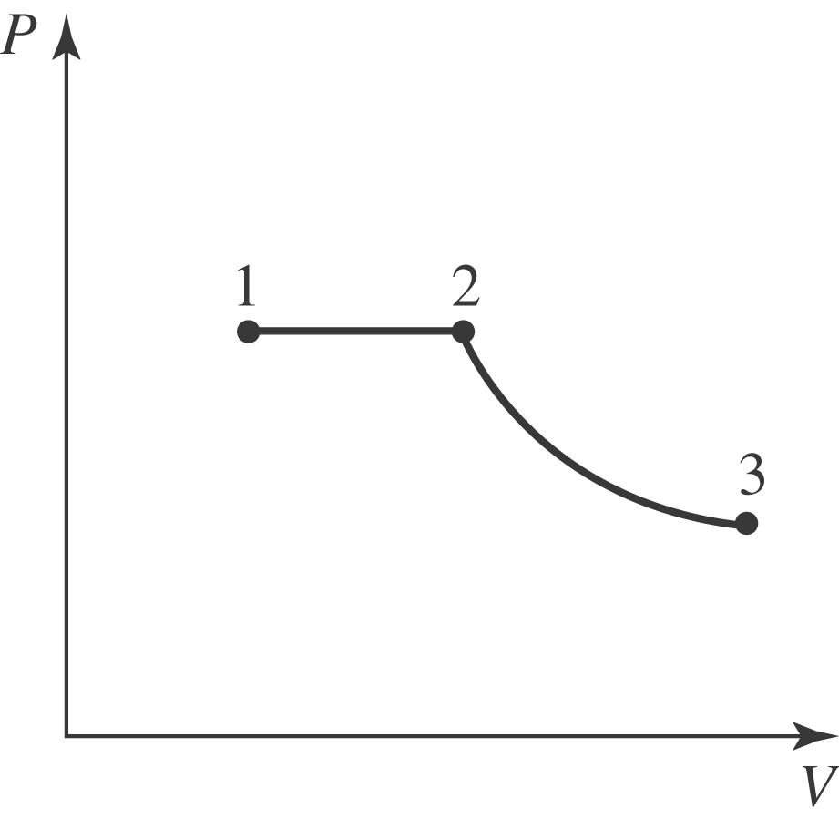

b) No heat is supplied during the adiabatic expansion; during the isobaric expansion, the heat added is 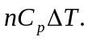 The Kelvin temperature doubles, so 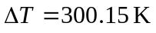 and c) For the entire process, 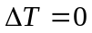 and so 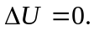 d) If 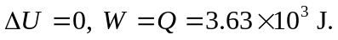 e) During the isobaric expansion, the volume doubles. During the adiabatic expansion, the temperature decreases by a factor of two, and from 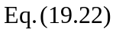 the volume changes by a factor of 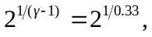 and the final volume is 